List of Mistakes\n

\n

Canning\n

* Not having enough right tools for canning

Having the right tools for canning is a great way for beginners to learn the basics of safety procedures and to enjoy the process of canning without harm. Ultimately, it is better for beginners to purchase enough tools for effective measures in all types of canning.\n

\n

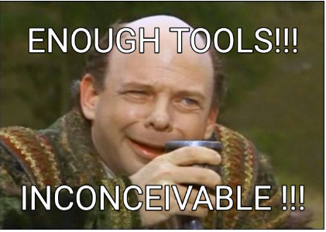

\n

* Using bad quality jars

Jars can make or break the process of canning. It can be said that wastage is a big factor in preserving foods. Picking certified jar brands can ensure that wastage can be less when storing foods. Kerr or Ball are often sought-after by all types of enthusiasts for their robust and trustworthy products.\n

\n

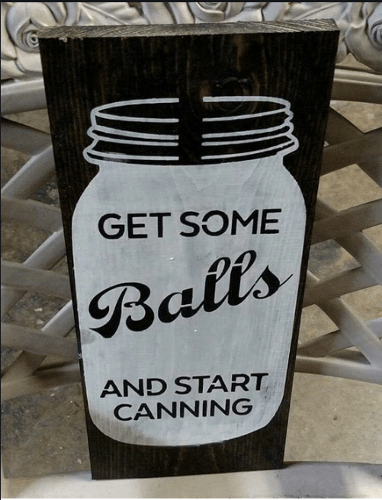

\n

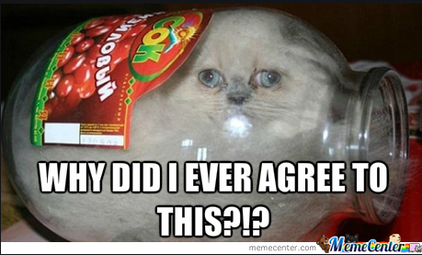

\n

* Using an electric pressure canner

<https://nchfp.uga.edu/publications/nchfp/factsheets/electric_cookers.html> \n

\n

An electric pressure canner sounds like an amazing idea when starting out as a canner. However, the USDA has warned against electric pressure canners when creating home-canned low-acid food because of their known dangers of increasing the risk of botulism. This is the case when environments with little oxygen can encourage the growth of bacteria often found in low acid foods. The tight space or vacuum of the pressure cooker can be an issue for pressure canning due to the high risk of botulism. Furthermore, the variables pressure and heat distribution determine the temperature of the cans. The process times also include the cool-down. Electric pressure canners can shorten the duration of cooldown which can make the food under-processed. Electric canners do display the value of the temperature but the accuracy of the appliance is always questioned. High-end pressure canners may try to solve these issues, but the risk of botulism is still high. Use electric pressure canners with caution.\n

\n

* Not taking the elevation of location into account when pressure canning

Pressure is proportional to the elevation of the location when pressure canning. If the canner follows the standards of pressure canning it becomes clear that heat distribution becomes more difficult at higher altitudes. One of the best reference charts on pressure canning can be found on the NCHP homepage.\n

\n

* Not having enough pressure in pressure canning

Pressure ensures good heat distribution so that microorganisms can be thoroughly killed during canning. Low-acid foods need to be canned properly to reduce the risk of botulism.\n

\n

* Failing to measure temperature or the time accurately

Measurements can be inaccurate if the canner does not regularly measure the temperature during canning. Unseen factors such as the stove turning off or the canning not having enough heat distribution or time is important to address especially for beginners.\n

\n